Social Bite
Software Requirements Specification



Group Id/ Names: Rai Muneeb 20-CS-36
Ahmed Naeem 20-CS-21
Fahad Zafar 20-CS-18
Supervisor Name: Mam Aziza Butt.
Revision History

Date (dd/mm/yyyy) | Version | Description | Author
20/12/2023 | 1.0 | Social Bite  The Social Bite app aims to connect food enthusiasts by providing a platform where users can share their favorite recipes, discover new culinary trends, and engage in a vibrant community. The app will allow users to create profiles, post recipes, follow others, and participate in discussions related to food and cooking. | Rai Muneeb 36  Ahmed Naeem. 21  Fahad Zafar 18

Table of Contents

- Scope
- Functional Requirements Non-Functional requirements
- Use Case Diagram
- Usage Scenarios
- Adopted Methodology
- Methodology flow Diagram
- Work Plan (Use MS Project to create Schedule/Work Plan)

SRS Document

1. Scope

The Social Bite app aims to connect food enthusiasts by providing a platform where users can share their favorite recipes, discover new culinary trends, and engage in a vibrant community. The app will allow users to create profiles, post recipes, follow others, and participate in discussions related to food and cooking.

2. Functional Requirements

2.1 User Management

Registration: Users can create accounts with a unique username and password.

Profile Management: Users can update their profiles, add a profile picture, and view other users' profiles.

Authentication: Secure login with password protection.

2.2 Recipe Management

Create Recipe: Users can post their recipes, including ingredients, steps, and images.

Search and Filter: Users can search for recipes based on ingredients, cuisine, or difficulty level.

Comments and Ratings: Users can comment on recipes and provide ratings.

2.3 Social Features

Follow/Unfollow: Users can follow and unfollow other users.

Activity Feed: Users receive updates on the activities of the users they follow.

Messaging: Users can send direct messages to each other.

3. Non-Functional Requirements

Performance: The app should load recipes and user profiles swiftly, even during peak usage times.

Security: User data and passwords must be securely stored. HTTPS encryption is mandatory.

Scalability: The app should handle a growing user base.

4. Use Case Diagram

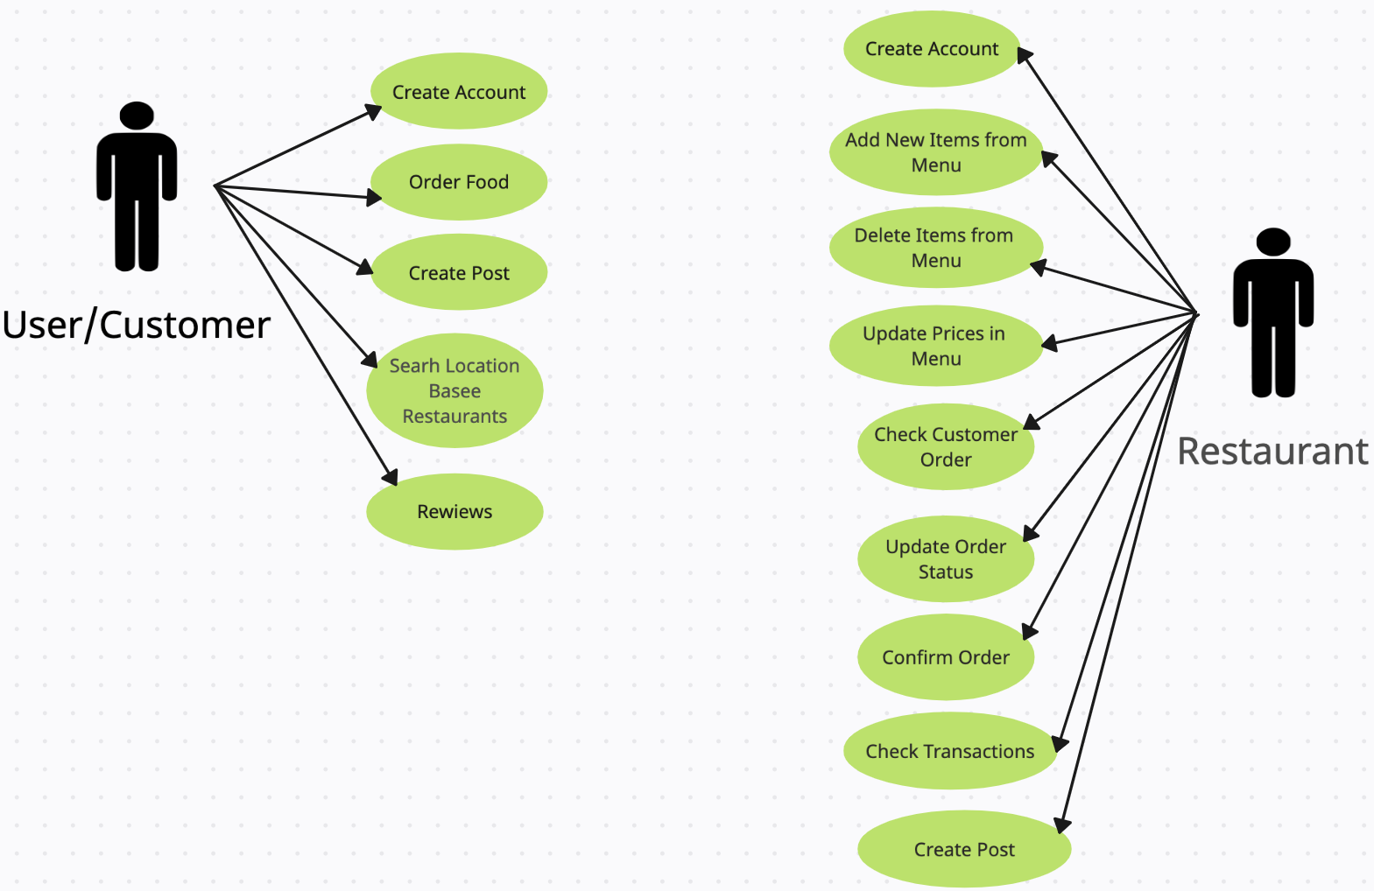
5. Usage Scenarios

5.1 Scenario: User Posts a Recipe

User logs in.

User navigates to the "Create Recipe" section.

User enters recipe details and uploads images.

User clicks "Post" to share the recipe with the community.

5.2 Scenario: User Interacts with Others

User logs in.

User explores the activity feed to discover new recipes from followed users.

User leaves comments on recipes.

User sends a direct message to another user.

5.3 Community Engagement for Restaurants:

- Restaurant owners post live updates on new dishes.
- Respond to customer reviews in real time.
- Organize exclusive events to foster community engagement.
5.4 Instantaneous Order Updates:

- Users receive instant notifications about order confirmation and preparation status.
- Track the estimated delivery time in real time.
5.5 Special Promotions and Events:

- Users enjoy exclusive promotions and events from their favorite restaurants.
- Receive notifications about limited-time discounts and special menus.

6. Adopted Methodology

The Agile development methodology will be adopted for the Social Bite app. It allows for iterative development, adapting to changing requirements, and continuous user feedback.

Iterative method:

Start with basic functionalities like user authentication and restaurant listing. Iterate and enhance features based on feedback and evolving requirements.

Adaptability:

Regularly assess the market and user needs, adapting the app accordingly.Be open to adjusting priorities based on emerging trends or user feedback.

Continuous User Feedback:

Implement feedback loops with potential users, restaurants, and riders. Regularly conduct usability testing sessions.

Cross-Functional Teams:
Assemble teams with diverse skills (developers, designers, testers). Foster collaboration and communication between team members.
Prioritized Product Backlog:
Maintain a backlog of features and enhancements based on priority. Regularly review and reprioritize the backlog to align with business goals.
Time-Boxed Sprints:

Plan development in fixed time increments (sprints).Break down tasks into manageable user stories.Review progress at the end of each sprint, adapting plans as needed.

Continuous Integration and Testing:
Implement continuous integration practices to merge code frequently.Conduct automated and manual testing throughout development.Use test-driven development (TDD) to catch issues early in the development cycle.
Focus on Customer Value:

Prioritize features that directly impact the customer experience.Regularly assess the app's usability and satisfaction among users.

7. Methodology Flow Diagram

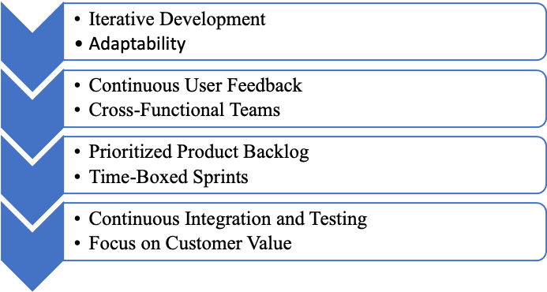

8. Work Plan

A detailed work plan using MS Project will be created, outlining tasks, dependencies, and timelines. It will include phases such as planning, design, development, testing, and deployment.

