Deep Fake Audio Detection

SRS Document



Submitted by:

Hannan Haris
2020-UET-NFC-BSc-CS-10

Muhammad Rehan Imtiaz
2020-UET-NFC-BSc-CS-13
Muzammil Ramzan
2020-UET-NFC-BSc-CS-40

Supervised by:

Prof Dr. Sultan Zia

Signature:

Department of Computer Science

NFC Institute of Engineering and Fertilizer Research.

Revision History

Date (dd/mm/yyyy) | Version | Description | Author
19/12/2023 | 1.0 | The "Deepfake Audio Detection System" is a web-based solution utilizing advanced machine learning and audio signal processing to evaluate the authenticity of user-uploaded audio files. It generates a confidence score indicating the percentage of authenticity, with applications spanning media, cybersecurity, law enforcement, entertainment, legal services, and public trust protection. | 20-CS-10 Hannan  20-CS-13 M Rehan  20-CS-40 Muzzamil

Table of Contents

- Scope
- Functional Requirements Non Functional requirements
- Use Case Diagram
- Usage Scenarios
- Adapted Methadology
- Work Plan

- Scope of Project:
The "Deepfake Audio Detection System" aims to develop a web-based solution that identifies and assesses the authenticity of audio content. The system will analyze user-uploaded audio files using advanced machine learning and audio signal processing techniques, providing users with a confidence score indicating the percentage of authenticity. The project's scope includes creating a user-friendly web application applicable in various domains such as media, cybersecurity, law enforcement, entertainment, legal services, and public trust protection.

2. Functional Requirements:
- Upload Audio File:
Users can conveniently upload audio files for analysis.

- Audio Analysis:
Machine learning models will analyze the uploaded audio for signs of manipulation or deception.
The system will utilize audio signal processing techniques to enhance accuracy.

- Confidence Score Calculation:
The system will calculate and present a confidence score as a percentage.
A higher percentage indicates higher authenticity, and vice versa.

3. Non-Functional Requirements:
- Performance:
The system should process audio files efficiently and provide timely results.

- Security:
User data and analysis results must be protected.

- Scalability:
The system should be scalable to handle an increasing number of users and audio files.

- Usability:
The web interface should be intuitive for users with varying technical expertise.

4. Use Case Diagram:

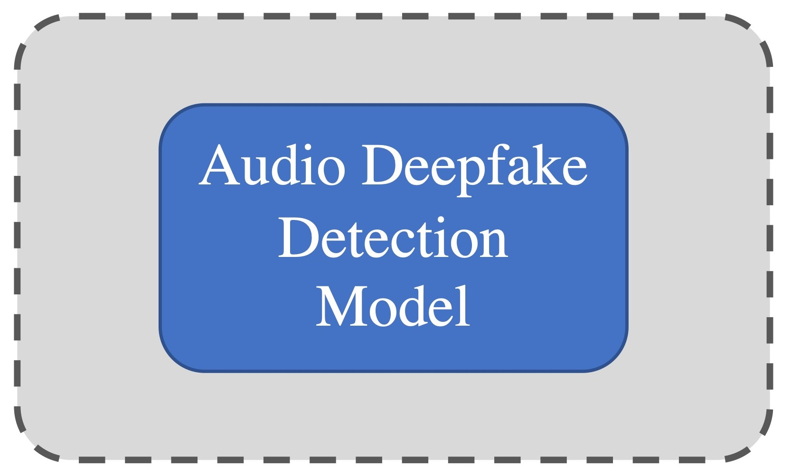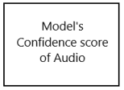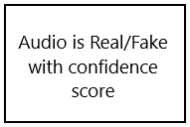
User Interaction Model Analysis Confidence Score Generation Result’s Presentation

5. Usage Scenarios:

User Interaction | Description
Upload Audio File | The conglomerate, facing the challenge of ensuring the authenticity of diverse audio content, uploads an audio file containing a crucial statement from a public figure, relevant to a breaking news story.

Model Analysis | Description
Analyzing Audio | The system utilizes machine learning models and audio signal processing techniques to analyze the uploaded audio, detecting any signs of manipulation or deception. This process involves assessing features and patterns within the audio data.

Confidence Score Generation | Description
Model Provided Output | The system generates a confidence score, presenting it as a percentage to indicate the likelihood of authenticity. In this scenario, the user gains insights into the reliability of the public figure's statement, crucial for maintaining credibility in reporting.

Result’s Presentation | Description
Audio Classification & presenting the result. | Utilizing the confidence score as a decisive metric, the user employs audio classification to make informed decisions spanning various domains. In a specific use case scenario, if the model is less than 50 percent confident about audio is real , it categorically identifies the audio as fake, and vice versa. providing a clear and actionable result for the conglomerate's decision-making process.

- Adapted Methadology
- Requirements Gathering:
Comprehensive identification of audio requirements, including user-uploaded audio file acceptance, machine learning model utilization, and confidence score provision.
- Risk Analysis:
Continuous assessment of risks associated with deepfake audio detection, allowing for proactive identification and mitigation strategies.

- Design:
Requirements Gathering

Development /
Implementation

Testing

Improvements

Launch

- Implementation:
Actual coding and development using Python as the primary programming language, with Django and Streamlit for web development and Librosa library for audio signal processing.
- Testing:
Rigorous testing to ensure the system functions as intended, identifying and modiying defects to deliver a reliable Deepfake Audio Detection System.
- Deployment:
System deployment for user access, enabling convenient uploading of audio files and initiating the analysis process using integrated machine learning models.
- Maintenance:
Ongoing support and updates of ML models to address any issues, ensuring the system's optimal performance and reliability.

- Work Plan

